**Change email test case**

**Goal:**

As a tester, I want to verify if the Change Email form is working correctly, and if the formulary is filled properly.

**Background:**

Change email page is responsible for changing an email to a different one required by the user.

**Steps to Reproduce**

1. Go to <https://www.find-a-house.nl/en/home> and click on the menu bar.

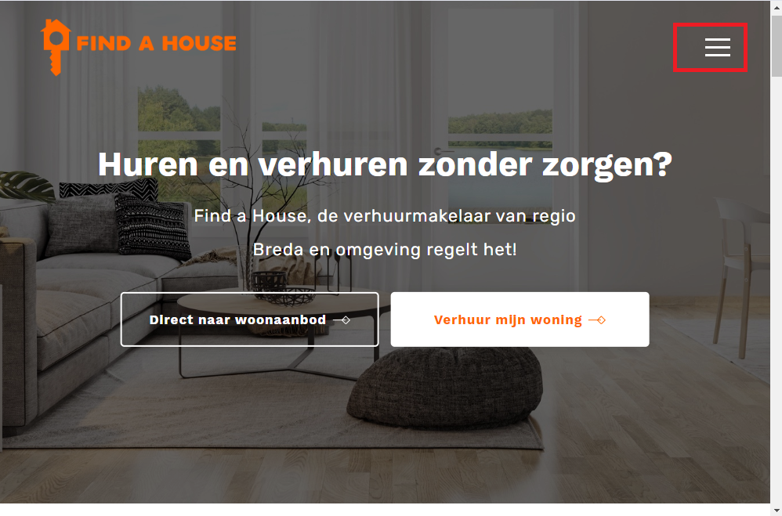

2. Click on the “Inloggen” Button and then open Login page

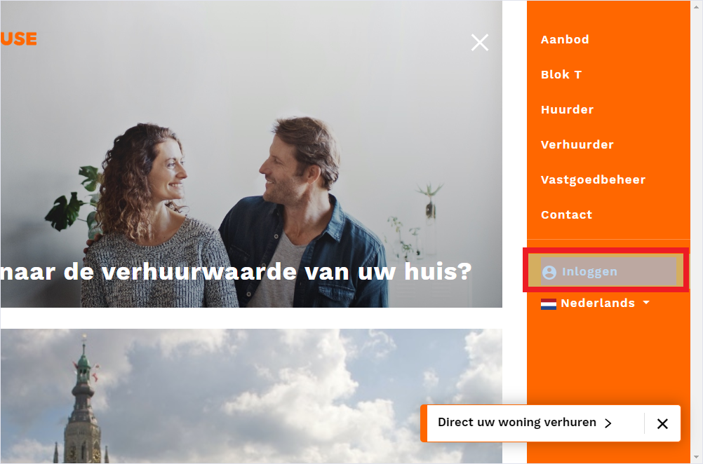

3. Fill the form with your email-address and password, then click on the “Inloggen” Button

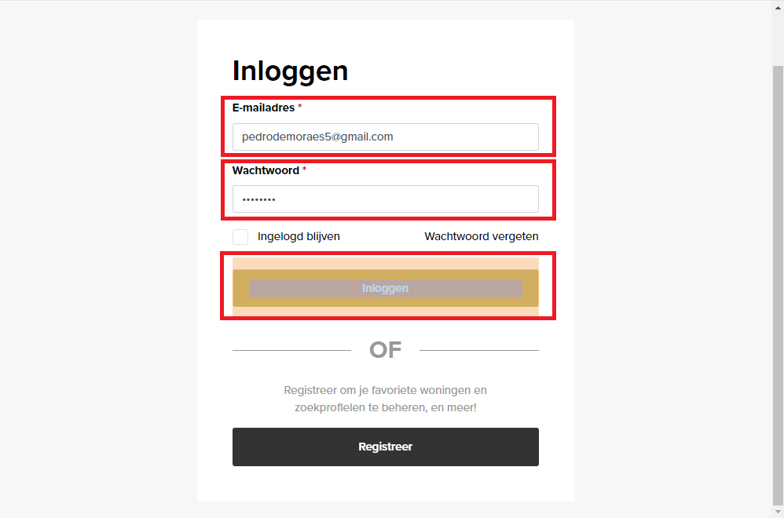

4. After effectuating Login click at “My gegevens” button.

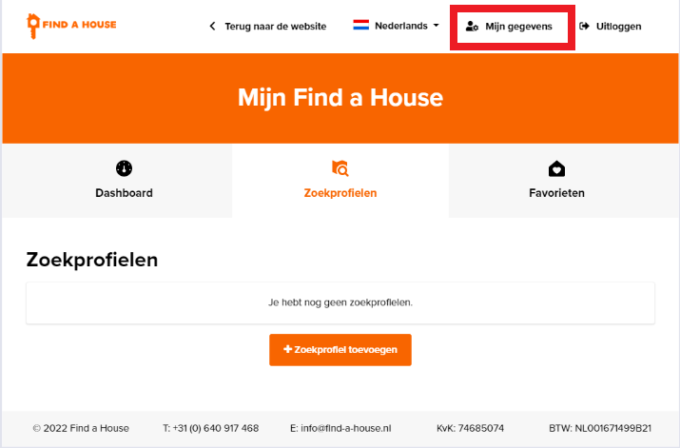

5. Should open the My Details page and click on the button “E-mailadres veranderen”.

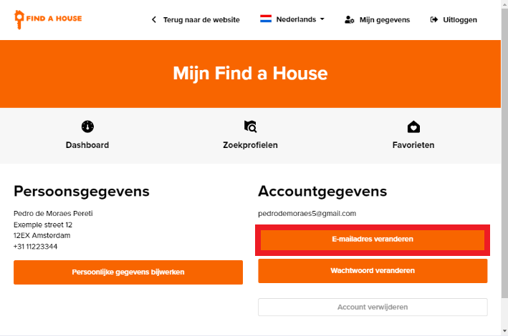

7. After filling with correct information, click again on the button “Opslaan”.

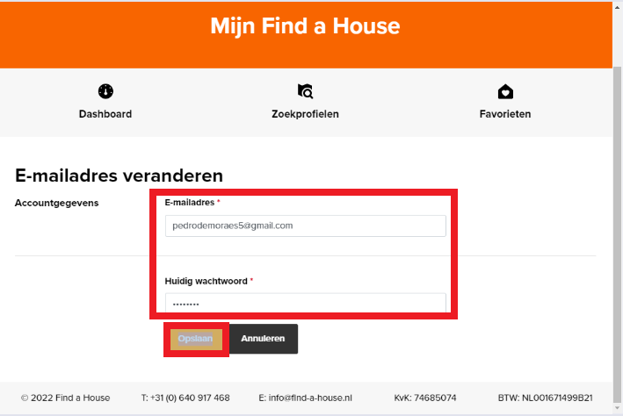

8. The procedure is finished and the page is redirected to My Details.

